Lab 2: Containerization & Kubernetes Orchestration
Task 1: Deploy an application to Kubernetes

1. Objective
Deploy the containerized Flask app to a Minikube cluster using Deployment and Service manifests and verify the running pods.

2. Start the cluster
Minikube was started with the Docker driver, and the app image was loaded into the cluster.
minikube start --driver=docker
minikube image load lab2-python-app:1.0
kubectl get nodes

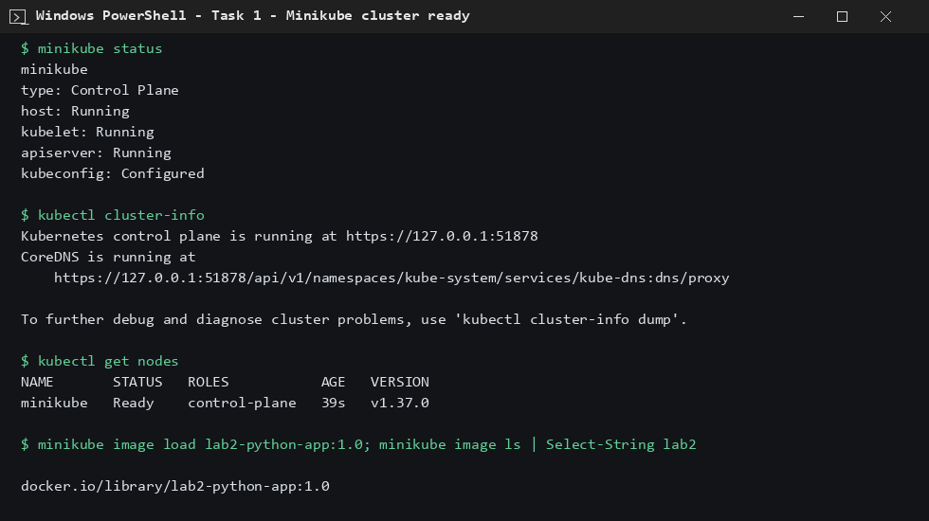
Figure 1: Minikube cluster is running, node is Ready

3. Manifests and deployment
deployment.yaml runs 2 replicas of the app; service.yaml exposes it as a NodePort service on port 30080.
kubectl apply -f k8s/
kubectl rollout status deployment/lab2-app

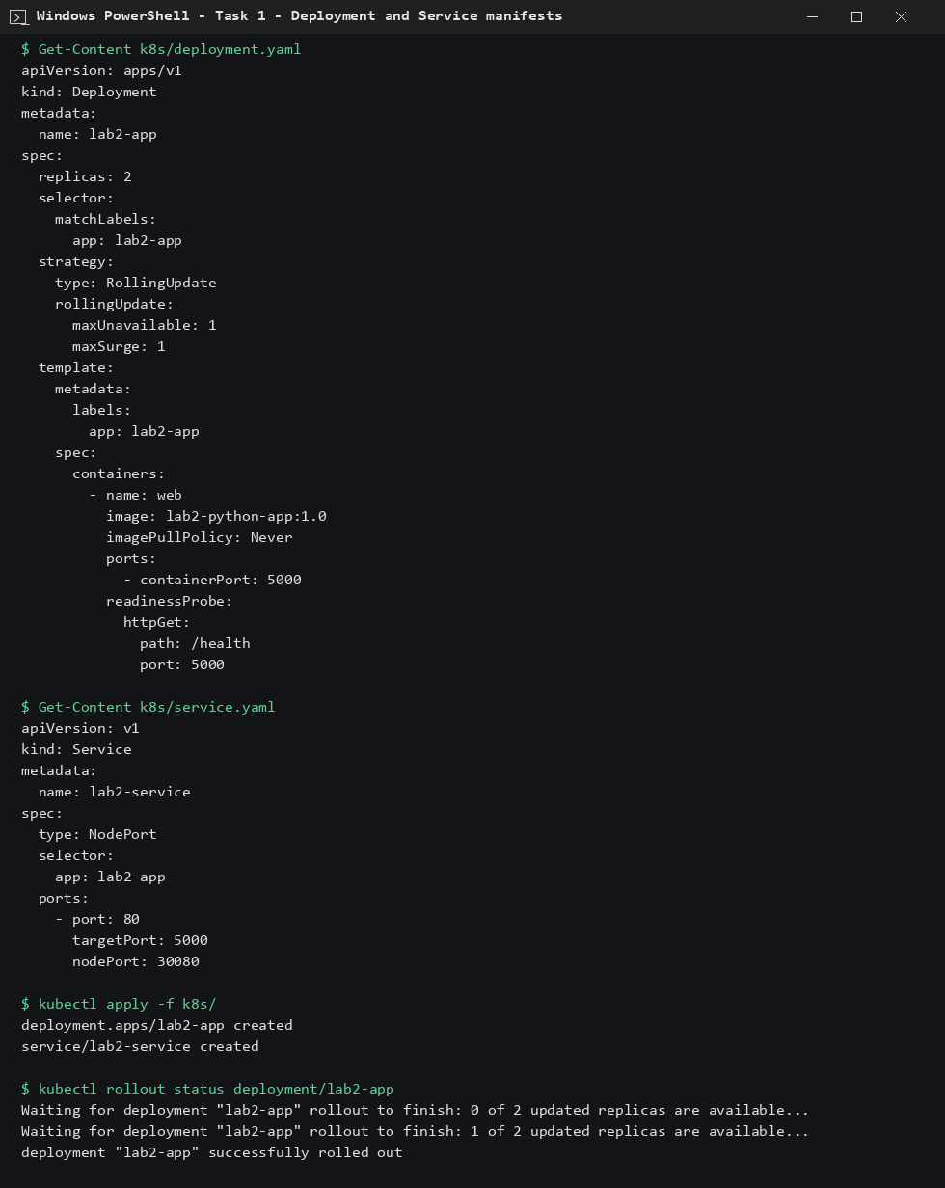
Figure 2: Deployment and Service manifests applied

4. Verify running pods
kubectl get deployments
kubectl get pods -o wide
kubectl get svc lab2-service

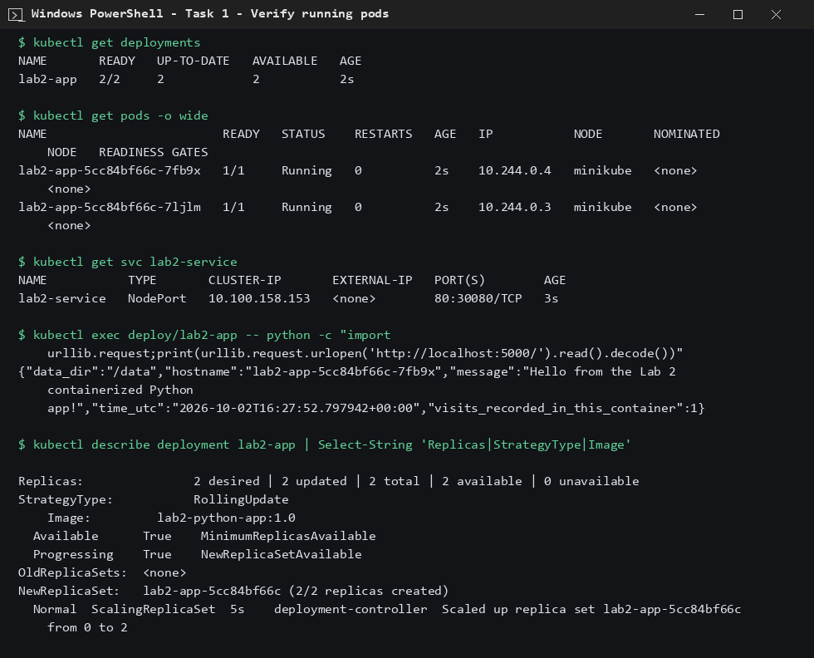
Figure 3: 2/2 pods Running, service created, app responds inside the pod

5. Conclusion
Both pods are in Running state (2/2 READY), the NodePort service is created, and the app returns its JSON response from inside the pod.

